11. Junction Object, Self Relationships, Hierarchical Relationship, Standard Object Relationships –

10 March 2022

Junction Object (N : N)

When an Object has two Masters (Parents), then that object is known as “Junction Object”.



OR

A junction object is **a custom object with two master-detail relationships**, and it is the key to making a many-to-many relationship.

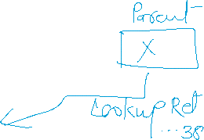

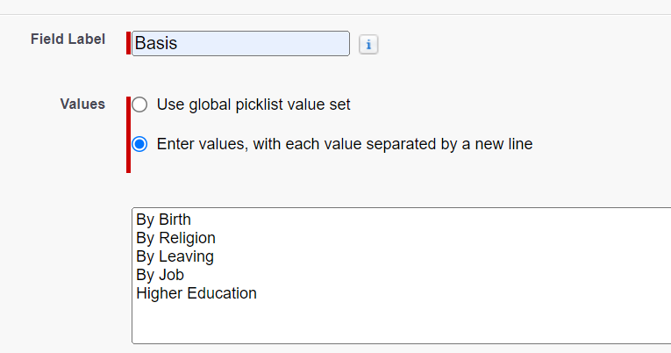

LIMITATION:

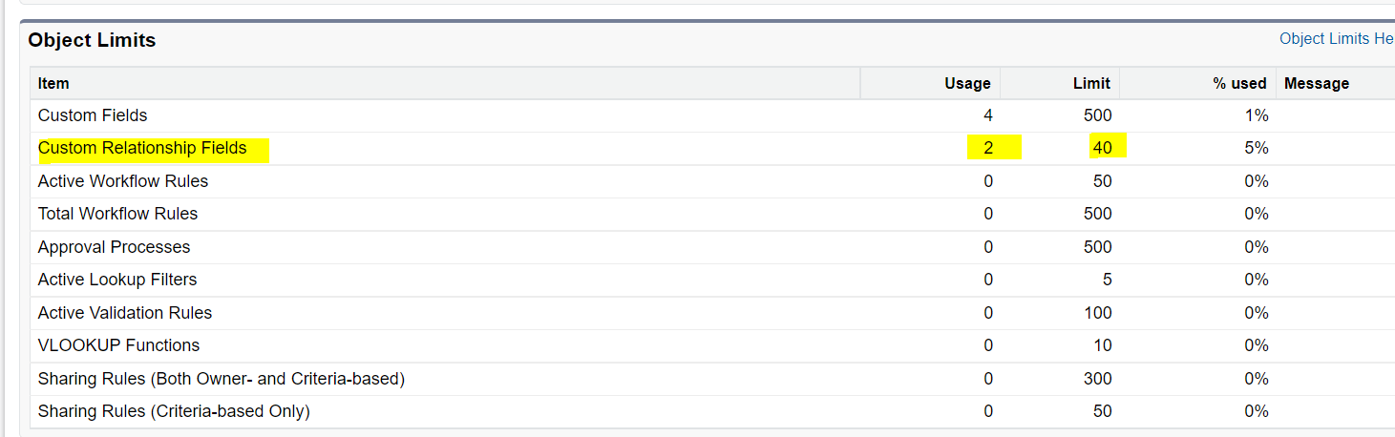

Total Relationships = Max 40

Master-Details Relationship = 02

Lookup Relationship = 38

Master-Details = 01 🡪 Lookup Relations = 39

Master Details = 0 🡪 Lookup Relationships = 40

Lookup Relation = 25 🡪 Master-Details = 02

**Master-Detail = 05** , Lookup Relation (THIS IS NOT POSSIBLE)



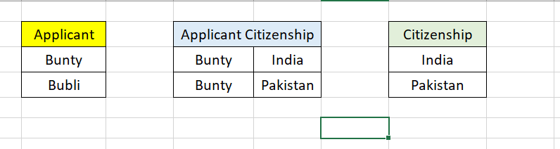















4] Self Relationship (1:1)

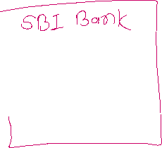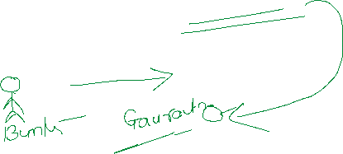

5] Hierarchical Relationship



When an object has lookup relationship with the User object, then the relationship is known as “Hierarchical Relationship”



Standard Objects:

|  |  |  |  |
| --- | --- | --- | --- |
| Object | Dikhanne Ke Daat | Khane Ke Daat | Actual Relationship |
| Account 🡨 🡪Contact  Roll Up Summary NOT POSSIBLE | Lookup Relation | Master – Details Relationship | Hybrid Relationship |
| Account 🡨 🡪 Opportunity  Rollup Summary YES | Lookup Relation | Master- Details Relations | Hybrid Relationship |

==================== RELATIONSHIP END ========================

